Faculty of Computer Science & Engineering

Assignment Number – 1

Name : Prajyot Chandrashekhar Bhamare. F.Y. B.Tech. Division 2 (B1)

Roll no.: 102032 PRN no.: 1032190054

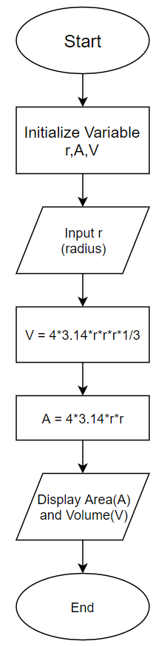Algorithm

Step 1: Start

Step 2: Initialize three variables r(radius), A(area), V(volume).

Step 3: Read input r(radius).

Step 4: Store value of volume in V which is = 4\*3.14\*r\*r\*r\*1/3.

Step 5: Store value of area in A which is = 4\*3.14\*r\*r.

Step 6: Display Volume and Area to the user.

Step 7: End

